**Lab 1: Introduction to Raspberry Pi, Basic I/O and ADC**

FirstName LastName & FirstName LastName

(Note: The following pictures, screenshots and tables are mainly for demonstration purposes. If an exercise doesn’t have the circuit or table, you can leave it blank.)

1. Exercise 1
   1. Circuit

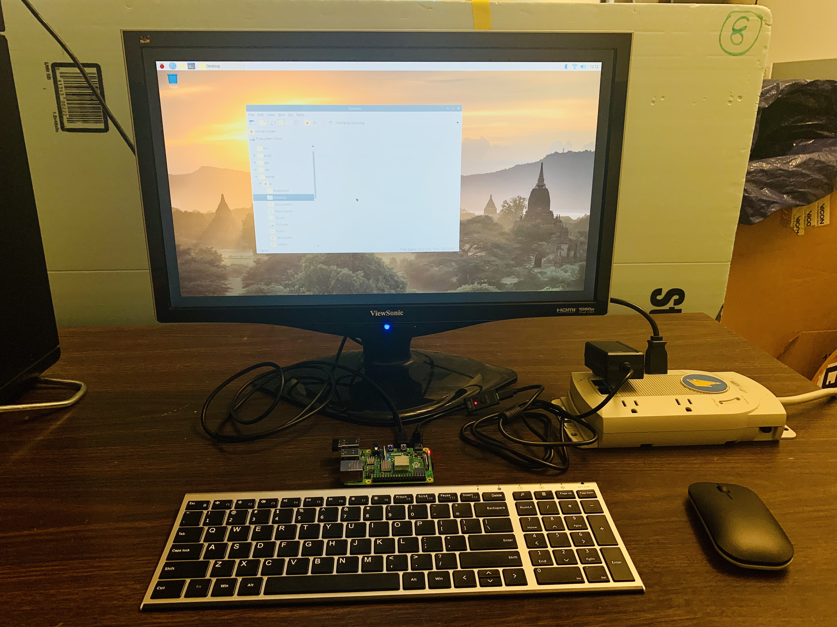

Figure 1: Demo for exercise 1

* 1. Screenshots & Tables & Results

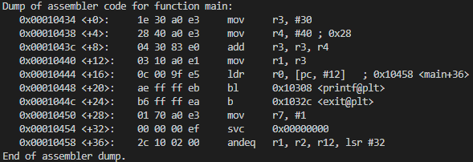

Figure 2: Memory address and machine code

Table 1 Current Results

|  |  |  |
| --- | --- | --- |
|  | R1 | R3 |
| Voltage (V) |  |  |
|  | LED 1 | LED 2 |
| Current (mA) |  |  |

1. Exercise 2.1
   1. Circuit

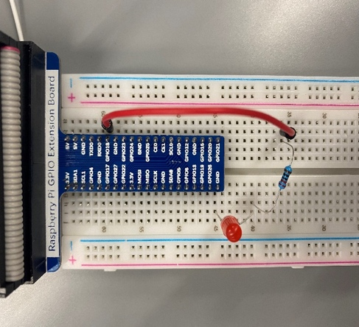

Figure 3: circuit for 2.1

* 1. Screenshots & Tables

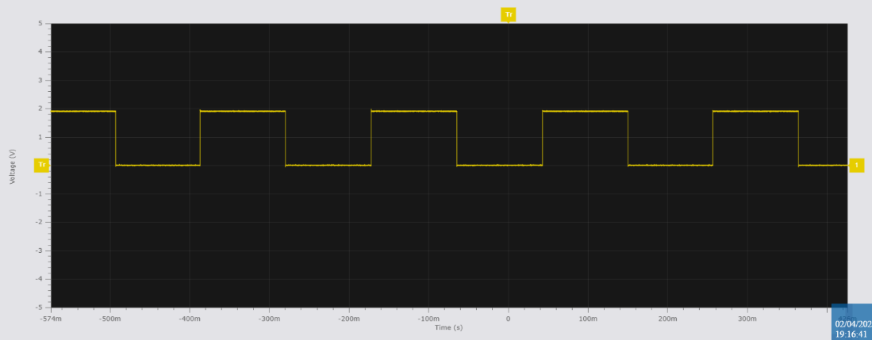

Figure 4: Image from oscilloscope

Table 2 Current Results

|  |  |  |
| --- | --- | --- |
|  | R1 | R3 |
| Voltage (V) |  |  |
|  | LED 1 | LED 2 |
| Current (mA) |  |  |

1. Exercise 2.2
   1. Circuit

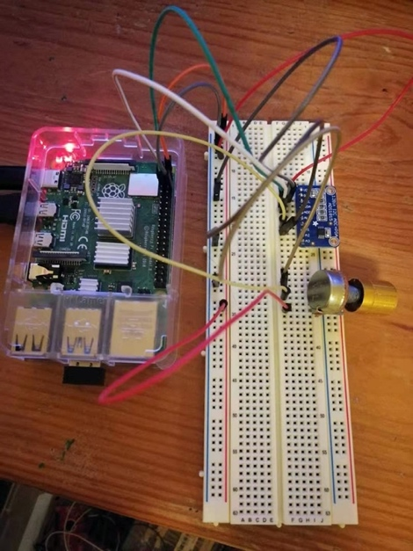

Figure 5: circuit for exercise 2.2

* 1. Screenshots & Tables

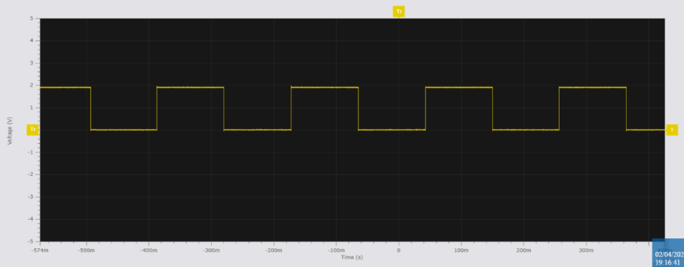

Figure 6: Image from oscilloscope

Table 3 Current Results

|  |  |  |
| --- | --- | --- |
|  | R1 | R3 |
| Voltage (V) |  |  |
|  | LED 1 | LED 2 |
| Current (mA) |  |  |

1. Supplemental Questions
   1. Briefly summarize what you learned from this lab.

XXXXX

* 1. Compare the advantages and disadvantages of machine code, assembly language and C/C++ programming language.

XXXXX

* 1. Explain the steps to generate machine code from a C/C++ code.

XXXXX

1. Ideas & Suggestions (Optional)
   1. Ideas:

XXXXX

* 1. Suggestions:

XXXXX

ACKNOWLEDGMENTS

I certify that this report is my/our own work, based on my/our personal study and/or research and that I/we have acknowledged all material and sources used in its preparation, whether they be books, articles, reports, lecture notes, and any other kind of document, electronic or personal communication. I/We also certify that this assignment/report has not previously been submitted for assessment anywhere, except where specific permission has been granted from the coordinators involved.

Author-1 Signature **FirstName LastName**

Author-2 Signature **FirstName LastName**

REFERENCES

1. XXXXX